文章编号：1007-5321（2015）01-0000-00
TD-LTE-A系统下行多用户CoMP联合预编码算法研究
XXX^{1,2}，XX¹，XX²
(1.xxxxxxxxxx,xx xxxxxx; 2.xxxxxx xxxxx，xx xxxxxx )
摘要: LTE-A中提出多点协作传输(CoMP)技术，对于基站可以通过多点协作发送、协作干扰消除等策略提高系统容量，X X X X X X X X X X X X X X X X X X X X X X X X X X，X X X X X X X X X X X X X X X X X X X X X X X X X X X X X X X X X X X X X X，X X X X X X X X X X X X X X X X X X，X X X X X X X X X X X X X X X X X X X X X X X X X X X X X X，X X X X X X，X X X X X X X X X X X X X X X X X X X X X X X X X X X X X X X X X X X X X X X X X X，X X X X X X X X X X X X X X X X X X，又能有效抑制用户及流间干扰.计算机仿真验证了该CoMP预编码矩阵联合设计算法能获得协作波束成形增益且具有较强的鲁棒特性.
关 键 词: 多点协作；信道状态信息；波束成形；广义特征矩阵
中图分类号: TN919.1 文献标志码: A
Research on CoMP Joint Transmission for Downlink MU-MIMO in TD-LTE-A
X X-X ^{1,2}, X X¹, X X²
（1.XXXXX, XX XXXXXX, X ; 2. XXXX, XXXX, XX XXXXXX,X )
Abstract: Coordinated multi-point transmission/reception(CoMP) is favored in LTE-A due to its capability in reducing the inter-cell interference and enhancing the throughput for cell-edge users significantly. X X X X X X X X X X X X X X X X X X X X X X X X X X X X X X X X X X X X X X X X X X X X X X X X X X X X X X X X X X X X X X X X X X X X X X X X X X X X X X X X X X X X X X X X X X X X X X X X X X X X X X X X X X X X X X X X X X X X X X X X X X X X X X X X X X X X X X X X X X X X X X X X X X X X X X X X X X X X X X X X X X X X X X X X X X X X X X X X X X X X X X X X X X X X X X X X X X X X X X X X X X X X X X X X X X X X X X X X X X X X X X X X X X X X X X X X X X X X X X X X X X X X X X X X X X X X X X X X X X X X X X X X X X X X X X X X X X X X X X X X X X X X X X X X X X X X X X X X X X X X X X X X X X X X X X X X X X X X X. Simulation confirms that the proposed precoding scheme offers significant throughput enhancement with coordinated beamforming gain, as well as good robustness.
Key words: coordinated multipoint transmission; channel state information；beamforming；generalized eigenmatrix

针对TD-LTE-A系统，学者们在3GPP的Release11中提出了多点协作传输(CoMP, coordinated multi-point transmission)技术，通过多个小区、多用户间的协作通信方式，能有效提升吞吐率，增强小区覆盖^{[1]}. X X X X X X X X X X X X X X X X X X X X X X X X X X X X X X X X X.目前，针对CoMP物理层关键技术的研究工作主要有CoMP系统容量分析^{[2]}、多用户CoMP(MU-CoMP, multi-user CoMP)下的用户配对策略^{[3]}及CoMP下预编码设计策略等^{[4]}.
针对MU-CoMP中的多用户配对问题，文献[3]提出了协作扇区门限筛选准则(CCTC, coordinated cell threshold criteria)，通过综合考虑各协作扇区信道状态信息(CSI, channel state information)特性，以最大化配对用户吞吐率性能设计CCTC策略，从而避免了信道正交性差的协作点对系统容量的恶化. X X X X X X X X X X X X X X X X X X X X X X X X X X X X X X X X X X X X X X X X X X X X X X X X X X X X X X X X X X X X X X X X X X X X X X X X X X X X X X X X X X X X X X X X X X X X X X X X X X X X X X X X X X X X X X X X X X X X X X X X X X X X X X X X X X X X X.信道互易性是TD-LTE/TD-LTE-A系统的一个重要特性，在针对信道互易性的CoMP算法研究中，文献[6]研究了闭环模型下SU-CoMP的协作波束成形算法，通过各传输点交互CSI，以最大化UE通信速率及最小化邻区干扰为目标函数，基于信泄比最大化准则推导波束成形向量设计方法，算法在高信噪比下能获得较明显的干扰抑制效果.
收稿日期: 2014-04-09
基金项目：XXXXXXXXXXX
作者简介: XXX(1979—)，X，XX，E-mail:XXXXXX；XX(1979—)，X，XXXXX.

作者简介: 作者姓名(1970-), 男, 职称. E-mail: abc@bupt.edu.cn
CoMP波束成形技术研究是CoMP物理层关键技术研究的一个重要内容，以往的研究重点多集中于CoMP信道容量、传输点筛选方法、多用户配对策略及面向单用户的多小区CoMP波束成形技术展开；X X X X X X X X X X X X X X X X X X X X X X X X X X X X X X X X X X X X X X X X X X X X X X X X X X X X X X X X X X X X X X X X X X X X X X X X X X X X X X X X X X X X X X X X X X X X X X X X X X X X X X X X X X X X X X.针对MU-CoMP中的多用户干扰问题，采用接收信号统计信干噪比(SINR, signal to interference plus noise ratio)最大化作为目标函数，将最大化接收SINR的预编码矩阵求解问题转化为正则矩阵束的广义特征向量求解问题，该预编码矩阵设计算法能有效支持MU-CoMP下的多流传输模式并能获得最大化SINR的性能增益.最后通过计算机仿真验证了算法的有效性.

数学模型简介
TD-LTE系统X X X X X X X X X X X X X X X X X X X X X X X X X X X X X X X X X X X X X X X X X X X X X X X X X X X X X X X X X X X X X X X X X X X X X X X X X X X X X X X X X X X X X X X X X X X X.接收信号解析式为
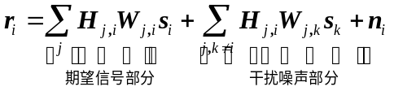     
其中：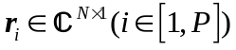为第个UE处接收到的信号矢量；X X X X X X X X X X X X X X X X X X X X X X X X X X X X X X X X X X X X X X X X X X X X X X X X X X X X X X X X X X X X X X X X X X X X X X X X X X X X X X X X X X X X X X X X X X X X X X X X X X X X X X X X X X X X X X X X X X X X X X X X X X X X X;
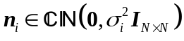为第个UE处的接收噪声矢量.
为了X X X X X X X X X X X X X X X X X X X 联合信道信息矩阵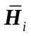为
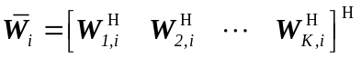
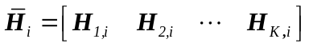
则式可以简化为
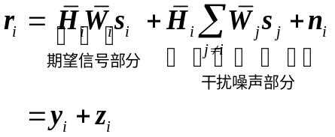
其中：X X X X X X X X X X X X X X X X X X X X X X X X X X X X X X X X X X X X X X X X X X X X X X X X X X X X X X X X，得到联合接收信号解析式为
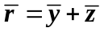                            
因此，X X X X X X X X X X X X X X X X X X X X X X X X X X X X X X X X X X X X X X X方法研究.

MU-CoMP联合传输算法分析
计算多用户下X X X X X X X X X X X X X X为
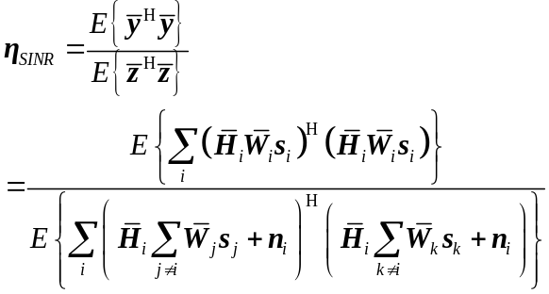
定义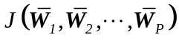 X X X X X X X X X X X X X X X X X X X X X X X X X X 化简为
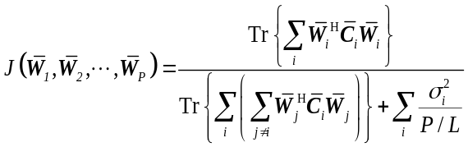

其中：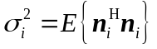，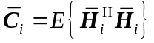.
简化式以便于分析，定义
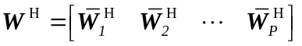      
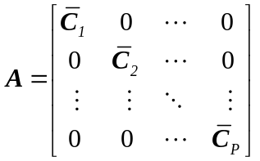
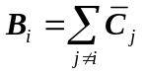
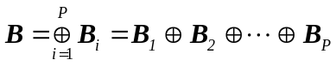
式中表示X X X X X X X X X X X X X X X X X X X X X X X X X分别化简为
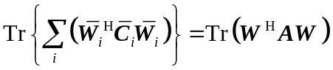    
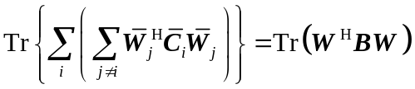   
定义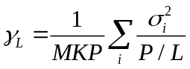，联立式、式和式则有
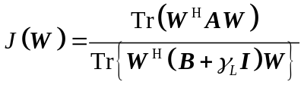   
至此，式(7)中最大化SINR的MU-CoMP 联合传输(JT, joint transmission)预编码矩阵设计问题就转化为最大化式的求解问题，将的求解表示为带约束极值优化问题，如式所示．
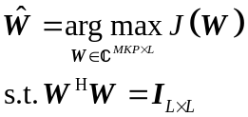                 

注意到X X X X X X X X X X X X X X X X X X X X X X X X X X X X X X X X X X X X X X X X X X X X X X X X X X X X X X X X X使式成立．
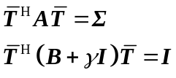               
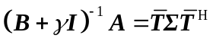            
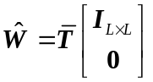                     
其中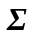为X X X X X X X X X X X X X X X X X X X X X对角矩阵.
令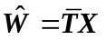，X X X X X X X X X X X X X X X X X X X X X X X X X X X X X X X X X X X X X X X X X X X X X X X X X X X X X X X X X X X X X X X X X X X X X X X X X X X X X X X X X X X X X X X X X X X X X X X X X X X X 算法步骤如下.

步骤1 计算X X X X X X X X X X相关矩阵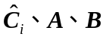；
步骤2 计算正则矩阵X X X X X X X X X X 特征值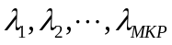；
步骤3 根据式X X X X X X X X 特征矩阵
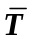；
步骤4 根据式X X X X X X预编码矩阵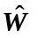．

仿真分析
链路级仿真X X X X X X X X X X X X X X X X X X X X X X X X X X X X X X X X X X X X X X X X X X X X X X X X X X X X X X X X X X X X X X X X X X X X X X X X X X X X X X X X X X X X X X X X X X X X X X X X X X X X X X X X X X X X X X X X X X X X X X X X X X X X X X X X X X X X X X X X X X进行仿真.
图1、图2分别为采用X X X X X X X X X X X X X X X X X X X X X X X X X X X X X X X X X X X X X X X X X X X X X X X X X X X X X X X X X X X X X X X X X X X X X X X X X X X X X X X X X X X X X X X X 进行对比.

-10
-5
0
5
10
15
20
0
2
4
6
8
10
12
14
16

CoMP JT UE1吞吐率
单小区无协作UE1吞吐率
CoMP JT UE2吞吐率
单小区无协作UE2吞吐率
吞吐率/(Mbit·s⁻¹)
信噪比/dB
MU-MIMO性能仿真比较(MCS为14)
图1 TM8传输模式下X X X X X X X X X X
TM8传输模式最大支持单个UE双流的传输能力. X X X X X X X X X X X X X X X X X X X X X X X X X X X X X X X X X X X X X X X X X X X X X X X X X X X X X X X X X X X X X X X X X X X X X X X X X X X X X X X X X X X X X X X X X X X X X X X X X X X X X X X X X X X X X X X X X X X X X X X X X X X X X X X X X X X.而对于图2中的单用户双流通信模式，用户吞吐率随着信噪比的增大不断提升，当信噪比大于15dB时，系统容量约可达30.5Mbit/s.相较单小区通信，单用户下的CoMP协作能获得3dB左右的性能增益.

-10
-5
0
5
10
15
20
0
5
10
15
20
25
30
35
SU-MIMO吞吐率性能仿真比较(MCS为14)
吞吐率/(Mbit·s⁻¹)

CoMP JT单用户吞吐率
单小区单用户吞吐率
信噪比/dB
图2 TM8传输模式下X X X X X X X X X X
仿真结果表明，X X X X X X X X X X X X X X X X X X X X X X X X X X X X X X X X X X X X X X X X X X X X X X X X X X X X X X X X X X X X X X X X X X X X X X X X X X X X X X X X X X X X X X X X X X X X X X X X X X X X X X X X X X X X X X X X X X 吞吐率性能.

结束语
LTE-A中提出了X X X X X X X X X X X X X X X X X X X X X X X X X X X X X X X X X X X X X X X X X X X X X X X X X X X X X X X X X X X X X X X X X X X X X X X X X X X X X X X X X X X X X X X X X X X X X X X X X X X X X X X X X X X X X X X X X X X X X X X X X X X X X X X X X X X X X X X X X X提升UE吞吐率.
参考文献:
- Lee J, Kim Y. Coordinated multipoint transmission and reception in LTE-advanced systems [M]. IEEE Communications Magazine, 2012, 50(11): 44-50.
- Anais V, Salah E E. Evaluating the capacity gains from coordinated multipoint transmission and reception[C]// 2010 Proceedings of the 8th International Symposium on Modeling and Optimization in Mobile, Ad Hoc and Wireless Networks. Avignon., France: IEEE, 2010: 603-609.
- Li Shiyuan, Cui Qimei, Wang Chao, et al. Coordinated cell threshold user pairing criteria for uplink CoMP MU-MIMO[C]// International Conference on Computer Science and Network Technology. Harbin, China: IEEE, 2011: 1740-1744.
- Patrick M, Gerhard P F. Coordinated multi-point on mobile communications from theory to practice [M]. New York: Cambridge University Press, 2011: 42-54.
- Masayuki H, Hui T, Tomohumi T, et al. Study of leakage-based precoding scheme that supports coordinated multi-point operation for LTE[C]// 2012 IEEE 75th Vehicular Technology Conference. Yokohama: IEEE, 2012: 1-5.
- Li Qiang, Yang Yang, Fang Shu, et al. Coordinated beamforming in downlink CoMP transmission system[C]// IEEE 5th International ICST on Communications and Networking in China. Beijing: IEEE, 2010: 1-5.

